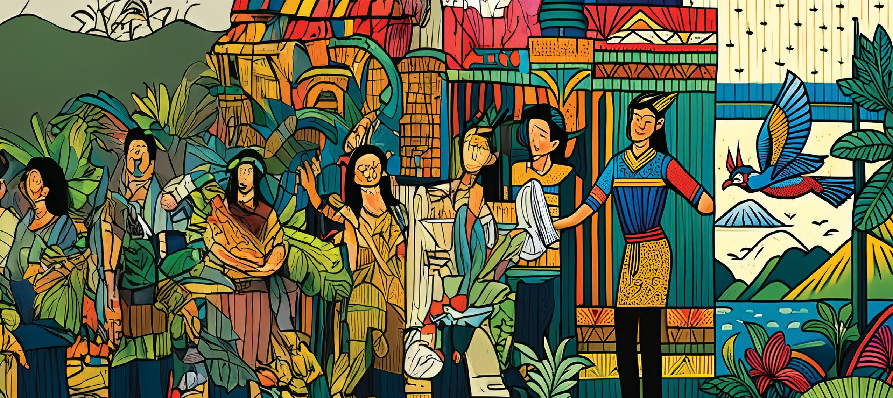

*Weekend Writing Workshop*

# WE TELL OUR STORY

FREE

*AI-Generated Image by José Carreón*

**F I L I P I N O V O I C E S I N H A W A I I**

Do you have stories to tell but want to know how best to write them?

Need help in organizing your thoughts and your life memories to share with your family, your friends, and even the world?

Overcome writing blocks and awaken inspiration. Discover and learn at intensive, fun writing workshops offered ***free*** by the Filipino Association of University Women (FAUW).

**OAHU**

*May 31-June 2*

**MAUI**

*July 26-28*

**BIG ISLAND**

*August 9-11*

**KAUAI**

*September 27-29*

**WORKSHO P SCHEDULE**

*5-7 p.m. Introduction to the Workshop Saturday, 8:30 a.m.-5:30 p.m.*

*Sunday, 8:30 a.m.-4:30 -5 p.m.*

Your participation in ***We Tell Our Story: Filipino Voices in Hawaii*** will become part of a collection to help others understand and appreciate where we came from, how we live, adapt, cope with challenges, and contribute to the overall history of Hawaii.

Workshop results will be shared at public forums and an online anthology.

**To register and for more information, contact:** Nanette Ruhter, [nanette48@gmail.com](mailto:nanette48@gmail.com) * Pepi Nieva 808-225-1219

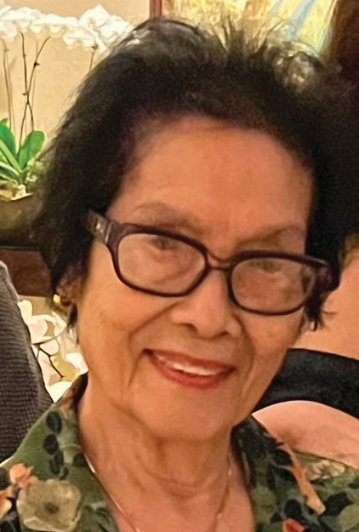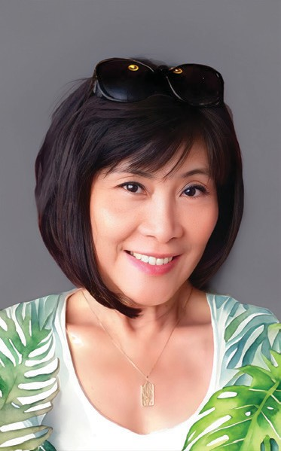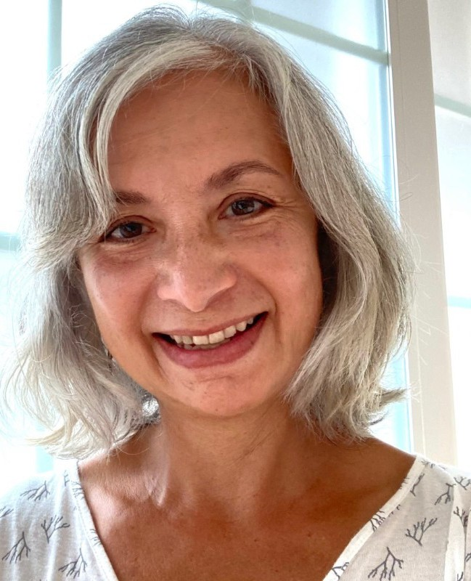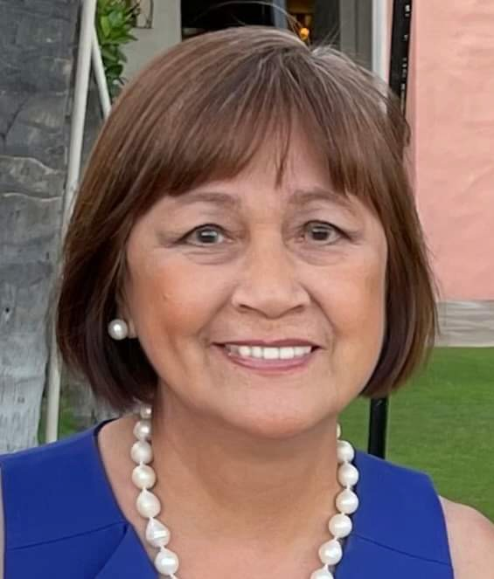

*Nanette Carreon-Ruhter*

*Margot Q. Adair*

*Virgie Chattergy*

*Michelle Cruz Skinner*

Workshops will be offered by expert teachers led by Nanette Carreon-Ruhter, who has 44 years of experience as an international English teacher. She directed Writing Workshops Across the Curriculum for international schoolteachers in Asia as an accredited consultant for the UC Berkeley Writing Project and the East Asia Writing Project.

Additional resource teachers: Margot Q. Adair, 30-year teaching veteran from Maryknoll School, Honolulu, Hawaii; Virgie Chattergy, professor emerita, University of Hawaii College of Education; Michelle Cruz Skinner, Punahou School English teacher for 24 years and author of three books.

***We Tell Our Story: Filipino Voices in Hawaii*** is offered by FAUW, a non-profit organization that aims to preserve and support the history, art and culture of Filipinos and Filipino Americans. Workshops and public forums are supported by a grant from the Hawaii Council for the Humanities, through support from the National Endowment for the Humanities.

Filipino Association of University Women

**-------------------------------------------------------------------------------------**

**REGISTER NOW**

**WE TELL OUR STORY: FILIPINO VOICES IN HAWAII**

PLEASE SEND via this [email to *nanette48@gmail.com*](mailto:email-nanette48@gmail.com) *or call Pepi Nieva at 808-225-1219*

o YES! I want to attend the weekend writing workshop!

o Please email me more information.

o Oahu o Maui o Big Island o Kauai

Name____________________________________________Phone__________________

Address__________________________________________________________________

Email____________________________________________________________________

*Workshop spaces are open on a first come, first served basis.*